BANKING_SYSTEM
THEME
It is used to maintain the main Banking activities, such as Customer details, Loans, Employees, transactions, bank accounts, and Branches.
MODULE
- Customers
- Branches
- Accounts
- Employees
- Loans
- Transactions

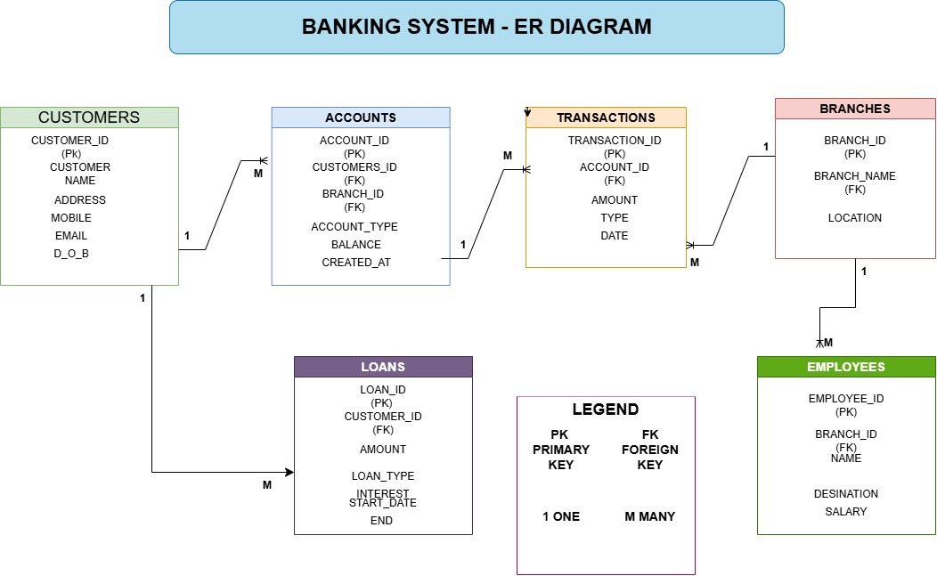

SAMPLE DATA
Customers
ID | Customer_Name | Address | Mobile | Email | D_O_B
1 | Gummidi Srinivasarao | Kasimkota | 9000270321 | Srinu@gmail.com | 1980-02-26
2 | Galla Apparao | Ankapalli | 9876543201 | Apparao@gmail.com | 1970-05-01
3 | Gummidi Nageswarao | Ankapalli | 9704567832 | Nagesh@gmail.com | 1981-09-05
4 | Nookala padma | Hyderabad | 5678987643 | Padma@gmail.com | 1995-02-02
5 | Nookala Naresh | Hyderabad | 678976594 | Naresh@gmail.com | 1997-08-04
6 | Chinni Sai | Vishakapatnam | 981283465 | Sai@gmail.com | 1997-01-13
7 | Balisipilli Sreenu | Kasimkota | 7680005010 | Sreenu@gmail.com | 1998-05-19

Branches
Branch_id | Branch_name | Location
101 | Main Branch | Hyderabad
102 | City1 Branch | Vishakapatnam
103 | City2 Branch | Ankapalli
104 | Local Branch | Kasimkota

Accounts
Account_id | Customer_id | Branch_id | Account_type | balance | Created_at
1001 | 1 | 104 | Savings | 75000.00 | 2024-01-10 10:30:00
1002 | 2 | 103 | Current | 45000.00 | 2024-02-15 11:00:00
1003 | 3 | 103 | Savings | 67000.00 | 2025-05-13 11:45:00
1004 | 4 | 101 | Current | 120000.00 | 2024-06-19 09:30:00
1005 | 5 | 101 | Savings | 150000.00 | 2025-07-02 15:30:00
1006 | 6 | 102 | Current | 125000.00 | 2024-03-25 14:25:20
1007 | 7 | 104 | Savings | 130000.00 | 2025-01-24 12:15:00

Employees
Employee_id | Branch_id | Employee_name | Designation | Salary
201 | 101 | Lalitha | Manager | 70000.00
202 | 101 | Ravi | Clerk | 35000.00
203 | 102 | Sai | Manager | 68000.00
204 | 102 | Prasad | Officer | 50000.00
205 | 103 | Soumya | Manager | 45000.00
206 | 104 | Vinila | Officer | 40000.00

Loans
Loan_id | Customer_id | Amount | Loan_type | Interest_rate | Start_date | End_date
301 | 1 | 500000.00 | Home Loan | 7.50 | 2024-01-15 | 2034-01-15
302 | 2 | 200000.00 | Personal Loan | 10.50 | 2024-03-29 | 2034-03-29
303 | 3 | 300000.00 | Home Loan | 7.25 | 2025-05-21 | 2035-05-21
304 | 5 | 750000.00 | Car Loan | 8.50 | 2025-04-23 | 2035-04-23
305 | 7 | 400000.00 | Personal Loan | 9.50 | 2026-01-18 | 2036-01-18

Transactions
Transaction_id | Account_id | amount | Type | Date
501 | 1001 | 12000.00 | Debit | 2024-02-26 12:30:00
502 | 1001 | 5000.00 | Credit | 2024-03-01 11:45:00
503 | 1002 | 15000.00 | Credit | 2025-03-05 09:30:00
504 | 1003 | 10000.00 | Debit | 2025-06-18 10:00:00
505 | 1003 | 20000.00 | Credit | 2025-07-12 10:30:00
506 | 1004 | 33000.00 | Debit | 2024-06-19 11:00:00
507 | 1005 | 45000.00 | Debit | 2025-08-23 12:20:00
508 | 1006 | 25000.00 | Credit | 2024-04-05 14:00:00
509 | 1007 | 30000.00 | Debit | 2025-03-23 15:00:00

Queries
#1: Display all records from the Customers table.
Select * from Customers;
output:
 | 1 | Gummidi srinivasarao | Kasimkota | 9000270321 | Srinu@gmail.com | 1980-02-26
 | 2 | Galla Apparao | Ankapalli | 9876543201 | Apparao@gmail.com | 1970-05-01
 | 3 | Gummidi NageswaraRao | Ankapalli | 9704567832 | Nagesh@gmail.com | 1981-09-05
 | 4 | Nookala Padma | Hyderabad | 5678987643 | Padma@gmail.com | 1995-02-02
 | 5 | Nookala Naresh | Hyderabad | 6789876594 | Naresh@gmail.com | 1997-08-04
 | 6 | Chinni Sai | Vishakapatnam | 9812873465 | Sai@gmail.com | 1997-01-13
 | 7 | Balisipilli Sreenu | Kasimmkota | 7680005010 | Sreenu@gmail.com | 1998-05-19

#2: Display all the name, phone number, and Email of all Customers.
Select Customer_name, Mobile ,Email
from Customers;
output:
Gummidi srinivasarao | 9000270321 | Srinu@gmail.com
Galla Apparao | 9876543201 | Apparao@gmail.com
Gummidi NageswaraRao | 9704567832 | Nagesh@gmail.com
Nookala Padma | 5678987643 | Padma@gmail.com
Nookala Naresh | 6789876594 | Naresh@gmail.com
Chinni Sai | 9812873465 | Sai@gmail.com
Balisipilli Sreenu | 7680005010 | Sreenu@gmail.com

#3: Display all customers who are from Hyderabad.
Select * from Customers
where address = 'Hyderabad';
output:
 | 5 | Nookala Naresh | Hyderabad | 6789876594 | Naresh@gmail.com | 1997-08-04
 | 4 | Nookala Padma | Hyderabad | 5678987643 | Padma@gmail.com | 1995-02-02

#4: Display all accounts whose account_type is Savings.
Select * from Accounts
where account_type = 'Savings';
output:
 | 1001 | 1 | 104 | Savings | 75000.00 | 2024-01-10 10:30:00
 | 1003 | 3 | 103 | Savings | 67000.00 | 2025-05-13 11:45:00
 | 1005 | 5 | 101 | Savings | 150000.00 | 2025-07-02 15:30:00
 | 1007 | 7 | 104 | Savings | 130000.00 | 2025-01-24 12:15:00

#5 : Display all accounts having a balance greater than $50000.
Select * from Accounts
where balance > 50000;
output:
 | 1001 | 1 | 104 | Savings | 75000.00 | 2024-01-10 10:30:00
 | 1003 | 3 | 103 | Savings | 67000.00 | 2025-05-13 11:45:00
 | 1004 | 4 | 101 | Current | 120000.00 | 2024-06-19 09:30:00
 | 1005 | 5 | 101 | Savings | 150000.00 | 2025-07-02 15:30:00
 | 1006 | 6 | 102 | Current | 125000.00 | 2024-03-25 14:25:20
 | 1007 | 7 | 104 | Savings | 130000.00 | 2025-01-24 12:15:00

#6 : Display all transactions where the transaction type is Credit.
Select * from Transactions
where type = 'Credit';

output:
 | 502 | 1001 | 5000.00 | credit | 2024-03-01 11:45:00
 | 503 | 1002 | 15000.00 | credit | 2025-03-05 09:30:00
 | 505 | 1003 | 20000.00 | credit | 2025-07-12 10:30:00
 | 508 | 1006 | 25000.00 | credit | 2024-04-05 14:00:00

#7: Display all Employees whose salary is greater than $40000.
Select * from Employees
where salary > 40000;
output:
 | 201 | 101 | Lalitha | Manager | 70000.00
 | 203 | 102 | Sai | Manager | 68000.00
 | 204 | 102 | Prasad | Officer | 50000.00
 | 205 | 103 | Soumya | Manager | 45000.00

#8: Display all customers born after 1998-01-01.
Select * from Customers
where D_O_B > '1998-01-01';
output:

 | 7 | Balisipilli Sreenu | Kasimmkota | 7680005010 | Sreenu@gmail.com | 1998-05-19

#9: Display all accounts in descending order of their balance.
Select * from Accounts
order by balance DESC;
output:
 | account_id | customer_id | branch_id | account_type | balance | created_at
 | 1005 | 5 | 101 | Savings | 150000.00 | 2025-07-02 15:30:00
 | 1007 | 7 | 104 | Savings | 130000.00 | 2025-01-24 12:15:00
 | 1006 | 6 | 102 | Current | 125000.00 | 2024-03-25 14:25:20
 | 1004 | 4 | 101 | Current | 120000.00 | 2024-06-19 09:30:00
 | 1001 | 1 | 104 | Savings | 75000.00 | 2024-01-10 10:30:00
 | 1003 | 3 | 103 | Savings | 67000.00 | 2025-05-13 11:45:00
 | 1002 | 2 | 103 | Current | 45000.00 | 2024-02-15 11:00:00

#10: Find the total number of Customers in the bank.
Select count(*) as total_customers
from Customers;
output:
total_customers
7

#11: find the total balance of all accounts.
Select sum(balance) as total_balance
from Accounts;
output:
total_balance
712000.00

#12: find the average account balance.
select avg(balance) as average_balance
from Accounts;
output:
average_balance
101714.285714

#13: find the highest and lowest account balance.
Select Max(balance) as Highest_balance,Min(balance) as Lowest_balance
from Accounts;
output:
 | Highest_balance | Lowest_balance
 | 150000.00 | 45000.00

#14: Display the number of accounts for each account_type.
Select account_type, count(*) as account_count from Accounts GROUP BY account_type;
Output:
 | account_type | account_count
 | Savings | 4
 | Current | 3

#15 : Display each account type and its total balance, but show only account types whose total blance is greater than $80000.
select account_type , sum(balance) as total_balance from accounts GROUP BY account_type Having sum(balance)>80000;
Output:
 | account_type | total_balance
 | Savings | 422000.00
 | Current | 290000.00

#16 : Display the customer name, account ID,account type and balance using Customers and Accounts
Select Customers.customer_name,Accounts.account_id,Accounts.account_type,Accounts.balance
from Customers join accounts on Customers.customer_id = Accounts.customer_id;
Output:
 | customer_name | account_id | account_type | balance
 | Gummidi srinivasarao | 1001 | Savings | 75000.00
 | Galla Apparao | 1002 | Current | 45000.00
 | Gummidi NageswaraRao | 1003 | Savings | 67000.00
 | Nookala Padma | 1004 | Current | 120000.00
 | Nookala Naresh | 1005 | Savings | 150000.00
 | Chinni Sai | 1006 | Current | 125000.00
 | Balisipilli Sreenu | 1007 | Savings | 130000.00

#17 : Display the customer name,transaction id,transaction amount,and transaction type using Customers,Accounts,and Transactions.
Select Customers.customer_name,Transactions.transaction_id,Transactions.amount,Transactions.type
From Customers join Accounts on Customers.customer_id = Accounts.customer_id
join Transactions on Accounts.account_id = Transactions.account_id;

Output:
 | customer_name | transaction_id | amount | type
 | Gummidi srinivasarao | 501 | 12000.00 | Debit
 | Gummidi srinivasarao | 502 | 5000.00 | credit
 | Galla Apparao | 503 | 15000.00 | credit
 | Gummidi NageswaraRao | 504 | 10000.00 | Debit
 | Gummidi NageswaraRao | 505 | 20000.00 | credit
 | Nookala Padma | 506 | 33000.00 | Debit
 | Nookala Naresh | 507 | 45000.00 | Debit
 | Chinni Sai | 508 | 25000.00 | credit
 | Balisipilli Sreenu | 509 | 30000.00 | Debit

#18 : Display the customer name, loan type, loan amount,and interest rate using Customers and Loans.
Select Customers.customer_name,Loans.loan_type,Loans.amount,Loans.interest_rate
from Customers join Loans on Customers.customer_id = Loans.Customer_id;

Output:
 | customer_name | loan_type | amount | interest_rate
 | Gummidi srinivasarao | Home Loan | 500000.00 | 7.50
 | Galla Apparao | Personal Loan | 200000.00 | 10.50
 | Gummidi NageswaraRao | Home Loan | 300000.00 | 7.25
 | Nookala Naresh | Car Loan | 750000.00 | 8.50
 | Balisipilli Sreenu | Personal Loan | 400000.00 | 9.50

#19 : Display the employee name , designation,branch name,branch location using Employees and Branches.
Select Employees.employee_name,Employees.designation,Branches.branch_name,Branches.location
from Employees inner join Branches on Employees.branch_id = Branches.branch_id;
Output:

 | employee_name | designation | branch_name | location
 | Lalitha | Manager | Main Branch | Hyderabad
 | Ravi | Clerk | Main Branch | Hyderabad
 | Sai | Manager | City1 Branch | Vishakapatnam
 | Prasad | Officer | City1 Branch | Vishakapatnam
 | Soumya | Manager | City2 Branch | Ankapalli
 | Vinila | Officer | Local Branch | Kasimkota

#20 : Display the names of Customers whose account balance is greater than the average balance of all accounts.
Select Customers.customer_name from Customers join Accounts on Customers.customer_id = Accounts.customer_id where Accounts.balance> (select avg(balance)
from Accounts);
Output:
customer_name
Nookala Padma
Nookala Naresh
Chinni Sai
Balisipilli Sreenu

